ORIGINAL RESEARCH | 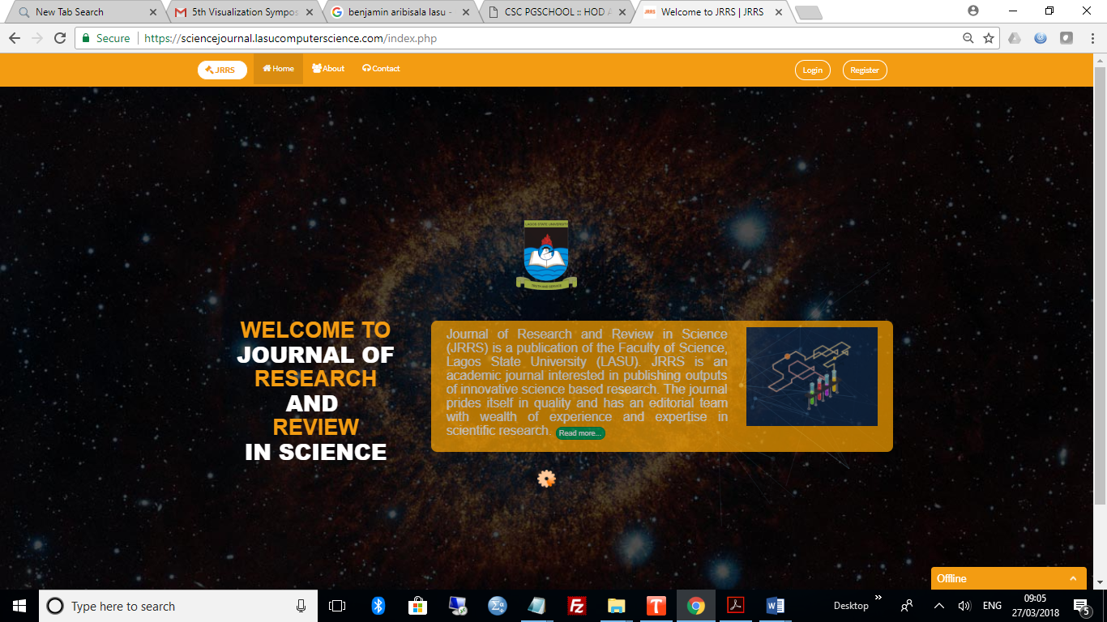  

Journal Title Here Journal Title Here Journal Title Here Journal Title Here Journal Title Here Journal Title Here
Journal Title Here
FirstName LastName for Author 1¹, FirstName LastName for Author 2², FirstName LastName for Author 3³, FirstName LastName for Author 4⁴, FirstName LastName for Author 5⁵, FirstName LastName for Author 6⁶, FirstName LastName for Author 7⁷, FirstName LastName for Author 8⁸

¹Department of Computer Science, Faculty of Science, Lagos State University, Nigeria  ²Department of Neuroimaging Sciences, Center for Clinical Brain Sciences, University of Edinburgh, Edinburgh UK  ³Department of Biochemistry, Faculty of Science, University of Lagos, Nigeria  ⁴Edinburgh Dementia Research Center, UK Dementia Research Institute, Edinburgh, UK  ⁵Department of Physics, Faculty of Science, Lagos State University, Nigeria  ⁶Department of Mathematics, Faculty of Science, University of Ibadan, Ibadan, Nigeria  ⁷Department of Psychology, School of Social Sciences, Heriot-Watt University, Edinburgh, UK  ⁸Alzheimer Scotland Dementia Research Centre, University of Edinburgh, Edinburgh, UK.  Correspondence  Olanrewaju Adigun Fagbohun, Department of Computer Science, Faculty of Science, Lagos State University, Nigeria.  Email:Olanrewaju.Fagbohun@lasu.edu.ng  Funding information  Grant sponsor and grant number: NUC Research Grant (nuc.edu.ng) (NUC1311/1) | Abstract:  Introduction: Give some background information of the study. This could be what is known about the project or field of study and the motivation or problem statement.  Aims: Clearly write the aims of this study. Sample: To correlate platelet count, splenic index (SI), platelet count/spleen diameter ratio and portal-systemic venous collaterals with the presence of esophageal varices in advanced liver disease to validate other screening parameters.  Materials and Methods: Please write main points of the research methodology applied. Sample: We included 63 patients (40 men, 23 women; age range 18-75 years) with liver cirrhosis and portal hypertension, with or without the medical history of gastrointestinal bleeding. Clinical as well as hematological examination (platelet count) and ultrasonography (gray as well as color Doppler scale including splenic index and splenorenal/ pancreaticoduodenal collaterals) was done besides upper GI endoscopy for esophageal varices. Platelet count/spleen diameter ratio was also calculated.  Results: Kindly make sure to include relevant statistics here, such as sample sizes, response rates, P-values or Confidence Intervals. Do not just say "there were differences between the groups". sample: Out of 63 patients, 36 patients with small varices (F1/F2) and 27 with larger (F3) varices were detected on endoscope. Significant increase in mean splenic index from low (86.7 +/- 27.4) to high (94.7 +/- 27.7) grade varices was documented. Opposite trend was found with platelets (120.2 +/- 63.5 to 69.8 +/- 36.1) and platelets/ splenic diameter ratio (1676.7 to 824.6) declining significantly.  Conclusion: Briefly summarize the finding(s) of your study. This could be in form of the impact, interpretation of your result, application of your result or a simple overall statements of what your finding(s)  To Keywords: 7 words maximum

All co-authors agreed to have their names listed as authors.
This is an open access article under the terms of the Creative Commons Attribution License, which permits use, distribution and reproduction in any medium, provided the original work is properly cited.
© 2018 The Authors. Journal of Research and Reviews in Science – JRRS, A Publication of Lagos State University

1. INTRODUCTION (Arial, Bold, 11 font, left aligned, caps)

(Arial, normal, 10 font, justified) (Detailed instruction about this section is given below. After reading these instructions, please delete this paragraph and begin typing your text here. If you are using copy-paste option then select ‘match destination formatting’ in paste option OR use ‘paste special’ option and select ‘unformatted Unicode text’ option).

Provide a factual background, clearly defined problem, proposed solution, a brief literature survey and the scope and justification of the work done.]

2. material and methods / experimental details / methodology (Arial, Bold, 11 font, left aligned, caps)

[(Arial, normal, 10 font, justified) (Detailed instruction about this section is given below. After reading these instructions, please delete this paragraph and begin typing your text here. If you are using copy-paste option then select ‘match destination formatting’ in paste option OR use ‘paste special’ option and select ‘unformatted Unicode text’ option).

Give adequate information to allow the experiment to be reproduced. Already published methods should be mentioned with references. Significant modifications of published methods and new methods should be described in detail. This section will include sub-sections. Tables & figures should be placed inside the text. Tables and figures should be presented as per their appearance in the text. It is suggested that the discussion about the tables and figures should appear in the text before the appearance of the respective tables and figures. No tables or figures should be given without discussion or reference inside the text.

Tables should be explanatory enough to be understandable without any text reference. Double spacing should be maintained throughout the table, including table headings and footnotes. Table headings should be placed above the table. Footnotes should be placed below the table with superscript lowercase letters.

Each figure should have a caption. The caption should be concise and typed separately, not on the figure area. Figures should be self-explanatory. Information presented in the figure should not be repeated in the table. All symbols and abbreviations used in the illustrations should be defined clearly. Figure legends should be given below the figures.

Some guidelines for Medical papers:
Randomized controlled trials should follow the CONSORT (Consolidated Standards of Reporting Trials) guidelines (http://www.consort-statement.org).

Case reports, case series, cross-sectional and other observational studies should follow the STROBE (Strengthening the Reporting of Observational Studies in Epidemiology) guidelines (http://www.strobe-statement.org). If the detailed methods are explicitly stated in the manuscript for single case studies, STROBE may be avoided.
Authors producing systematic reviews and meta-analyses should follow the PRISMA (Preferred Reporting Items for Systematic Reviews and Meta-Analyses) guidelines (http://www.prisma-statement.org).

Note: Review paper may have different types of subsections.

2.1 Subheading Subheading (ARIAL, BOLD, 11 FONT, LEFT ALIGNED) - second level heading.

2.1.1 Sub-subheading (ARIAL, BOLD, 10 FONT, LEFT ALIGNED, underlined)- third level heading.

2.1.1.1 Sub-sub-subheading (ARIAL, ITALICS, BOLD, 10 FONT, LEFT ALIGNED) - fourth level heading.]

3. results and discussion

[(Detailed instruction about this section is given below. After reading these instructions, please delete this paragraph and begin typing your text here. If you are using copy-paste option then select ‘match destination formatting’ in paste option OR use ‘paste special’ option and select ‘unformatted Unicode text’ option). Note: Review paper may have different types of subsections.

Results should be clearly described in a concise manner. Results for different parameters should be described under subheadings or in separate paragraph. Table or figure numbers should be mentioned in parentheses for better understanding.

The discussion should not repeat the results, but provide detailed interpretation of data. This should interpret the significance of the findings of the work. Citations should be given in support of the findings. The results and discussion part can also be described as separate, if appropriate.

Guideline for Reporting P values:
P is always italicized and capitalized.
i) Correct expression: (P = .05). Wrong Expression: (P < .05), unless P < .001.
ii) The P value should be expressed to 2 digits whether or not it is significant. If P < .01, it should be expressed to 3 digits.
iii) When rounding, 3 digits is acceptable if rounding would change the significance of a value (eg, P = .049 rounded to .05).
iv) Expressing P to more than 3 significant digits does not add useful information since precise P values with extreme results are sensitive to biases or departures.from the statistical model.
v) Reporting actual P values avoids this problem of interpretation. P values should not be listed as not significant (NS) since, for meta-analysis, the actual values are important and not providing exact P values is a form of incomplete reporting.
vi) Do not use 0 before the decimal point for statistical values P, alpha, and beta because they cannot equal 1.

Tables & figures should be placed inside the text. Tables and figures should be presented as per their appearance in the text. It is suggested that the discussion about the tables and figures should appear in the text before the appearance of the respective tables and figures. No tables or figures should be given without discussion or reference inside the text.

Tables should be explanatory enough to be understandable without any text reference. Double spacing should be maintained throughout the table, including table headings and footnotes. Table headings should be placed above the table. Footnotes should be placed below the table with superscript lowercase letters. Sample table format is given below.

Table 1. Physical, chemical and biological properties of experimental soil (0-20 cm)

Particulars | Value | Methods
Sand (%)  Silt (%)  Clay (%) | 61.3  21.4  17.3 | Pipette Method (Ogawa et al. 1990)
Bulk density, Mg m⁻³ | 1.64 | Core Sampler (Xu et al. 1992)
pH (1 : 2.5:: Soil : Water) | 5.20 | Glass Electrode pH Meter (Strogatz 2001)
Organic carbon (g kg⁻¹) | 2.9 | Glass Electrode pH Meter(Strogatz 2001)
Total N, % | 0.049 | Modified Kjeldahl Method (Majumder et al. 2022)
*Moisture content on oven dry weight basis

Each figure should have a caption. The caption should be concise and typed separately, not on the figure area. Figures should be self-explanatory. Information presented in the figure should not be repeated in the table. All symbols and abbreviations used in the illustrations should be defined clearly. Figure legends should be given below the figures.] A sample figure is given in figure 1.

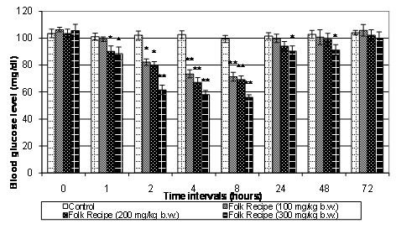

Fig. 1. Effect of different doses of aqueous extract of Folk Recipe (100, 200, 300 mg/kg) on blood glucose levels at different time intervals in normal rabbits
Test drugs: significant from normal control, * P < 0.05; ** P < 0.001
Mean ± S.E.M = Mean values ± Standard error of means of six experiments

3.1 Subheading Subheading (ARIAL, BOLD, 11 FONT, LEFT ALIGNED) - second level heading.

3.1.1 Sub-subheading (ARIAL, BOLD, 10 FONT, LEFT ALIGNED, underlined)- third level heading.

3.1.1.1 Sub-sub-subheading (ARIAL, ITALICS, BOLD, 10 FONT, LEFT ALIGNED) - fourth level heading.]

4. Conclusion

[This should briefly state the major findings of the study. If you are using copy-paste option then select ‘match destination formatting’ in paste option OR use ‘paste special’ option and select ‘unformatted Unicode text’ option]

AcknowledgEments

A brief acknowledgement section may be given after the conclusion section just before the references. The acknowledgments of people who provided assistance in manuscript preparation, funding for research, etc. should be listed in this section. All sources of funding should be declared as an acknowledgement. Authors should declare the role of funding agency, if any, in the study design, collection, analysis and interpretation of data; in the writing of the manuscript. If the study sponsors had no such involvement, the authors should so state.

Competing interests

Declaration of competing interest should be placed here. All authors must disclose any financial and personal relationships with other people or organizations that could inappropriately influence (bias) their work. Examples of potential conflicts of interest include employment, consultancies, honoraria, paid expert testimony, patent applications/registrations, and grants or other funding. If no such declaration has been made by the authors, JRRS reserves to assume and write this sentence: “Authors have declared that no competing interests exist.”.

Authors’ Contributions

Authors may use the following wordings for this section: “ ‘Author A’ designed the study, performed the statistical analysis, wrote the protocol, and wrote the first draft of the manuscript. ‘Author B’ and ‘Author C’ managed the analyses of the study. ‘Author C’ managed the literature searches…… All authors read and approved the final manuscript.”

Consent (where ever applicable)

No manuscripts will be peer-reviewed if a statement of patient consent is not presented during submission (wherever applicable).
This section is compulsory for medical journals. Other journals may require this section if found suitable. It should provide a statement to confirm that the patient has given their informed consent for the case report to be published. Journal editorial office may ask the copies of the consent documentation at any time.

Authors may use a form from their own institution or JRRS Copyright Form. It is preferable that authors should send this form along with the submission. But if already not sent during submission, we may request to see a copy at any stages of pre and post publication.

If the person described in the case report has died, then consent for publication must be collected from their next of kin. If the individual described in the case report is a minor, or unable to provide consent, then consent must be sought from their parents or legal guardians.

Authors may use the following wordings for this section: "All authors declare that ‘written informed consent was obtained from the patient (or other approved parties) for publication of this case report and accompanying images. A copy of the written consent is available for review by the Editorial office/Chief Editor/Editorial Board members of this journal."

Ethical approval (where ever applicable)

This section is compulsory for medical journals. Other journals may require this section if found suitable. If human subjects are involved, informed consent, protection of privacy, and other human rights are further criteria against which the manuscript will be judged. It should provide a statement to confirm that the authors have obtained all necessary ethical approval from suitable Institutional or State or National or International Committee. This confirms either that this study is not against the public interest, or that the release of information is allowed by legislation.

All manuscripts which deal with animal subjects must be approved by an Institutional Review Board (IRB), Ethical Committee, or an Animal Utilization Study Committee. , and this statement, and approval number, must accompany the submission. If required, author should be ready to submit a scanned copy of the IRB or Ethical Committee Approval at any stage of publication (Pre of post publication stage). The manuscript should contain information about any post-operative care and pain management for the animals.

For manuscripts involving animal experiments, Authors may use the following wordings for this section “All authors hereby declare that "Principles of laboratory animal care" (NIH publication No. 85-23, revised 1985) were followed, as well as specific national laws where applicable. All experiments have been examined and approved by the appropriate ethics committee”

All manuscripts which deal with the study of human subjects must be accompanied by Institutional Review Board (IRB) or Ethical Committee Approval, or the national or regional equivalent. The name of the Board or Committee giving approval and the study number assigned must accompany the submission. If required, author should be ready to submit a scanned copy of the IRB or Ethical Committee Approval at any stage of publication (Pre of post publication stage).

For manuscripts involving human experiments, Authors may use the following wordings for this section: “All authors hereby declare that all experiments have been examined and approved by the appropriate ethics committee and have therefore been performed in accordance with the ethical standards laid down in the 1964 Declaration of Helsinki.”

References

References must be listed at the end of the manuscript and numbered in the order that they appear in the text. Every reference referred in the text must also present in the reference list and vice versa. In the text, citations should be indicated using PLoS Reference style e.g. (Ogawa et al. 1990).

Only published or accepted manuscripts should be included in the reference list.
Articles submitted for publication, unpublished findings and personal communications should not be included in the reference list but may be mentioned in the text (e.g., T Nelson, Purdue University, USA, Unpublished results or personal communication). Avoid citing a “personal communication” unless it provides essential information not available from a public source, in which case the name of the person and date of communication should be cited in parentheses in the text. For scientific articles, obtain written permission and confirmation of accuracy from the source of a personal communication. Unpublished result which has been accepted for publication in any journal should be cited as "in press".
Journal name abbreviations should be those found in the NCBI databases (Link: http://www.ncbi.nlm.nih.gov/nlmcatalog/journals).

All references should follow the following style:

Reference to a journal:
For Published paper:

1. Hilly M, Adams ML, Nelson SC. A study of digit fusion in the mouse embryo. Clin Exp Allergy. 2002;32(4):489-98.

Note: List the first six authors followed by et al.
Note: Use of a DOI number for the full-text article is encouraged. (if available).
Note: Authors are also encouraged to add other database's unique identifier (like PUBMED ID).

For Accepted, unpublished papers.
Same as above, but “In press” appears instead of the page numbers.

1. Saha M, Adams ML, Nelson SC. Review of digit fusion in the mouse embryo. J Embryol Exp Morphol. 2009;49(3): (In press).

Note: List the first six authors followed by et al.
Note: Use of a DOI number is encouraged (if available).
Note: Authors are also encouraged to add other database's unique identifier (like PUBMED ID).

For Articles not in English
Forneau E, Bovet D. Recherches sur l'action sympathicolytique d'un nouveau dérivé du dioxane. Arch Int Pharmacodyn. 1933;46:178-91. French.

Reference to a book:

Personal author(s)
Rang HP, Dale MM, Ritter JM, Moore PK. 2003. Pharmacology. 5th ed. Edinburgh: Churchill Livingstone;

Editor(s) or compiler(s) as authors
Majumder, Dwijesh Kumar Dutta, and Dipankar Ray. 2022. Fundamentals of Medical Image Processing Using Matlab PHI Learning Pvt. Ltd.

Authored chapter in edited publication
Glennon RA, Dukat M. 2002. Serotonin receptors and drugs affecting serotonergic neurotransmission. In: Williams DA, Lemke TL, editors. Foye's principles of medicinal chemistry. 5th ed. Philadelphia: Lippincott Williams & Wilkins.

Reference to Web-resource or Electronic articles.
Hugo JT, Mondal SC. Parallels between tissue repair and embryo morphogenesis: a conceptual framework. Global Health. 2006;16:4. Accessed 29 March 2012.
Available: http://www.globalizationandhealth.com/content/1/1/14.

Anonymous. Parallels between tissue repair and embryo morphogenesis: a conceptual framework. Global Health. 2006;16:4. Accessed 29 March 2012.
Available: http://www.globalizationandhealth.com/content/1/1/14.

Reference to Organization as author
Diabetes Prevention Program Research Group. A study of digit fusion in the mouse embryo. J Embryol Exp Morphol. 2009;49(2):259–276.

Definitions, Acronyms, Abbreviations
Here is the Definitions section. This is an optional section.
Term: Definition for the term

REFERENCES SAMPLE
Majumder, Dwijesh Kumar Dutta, and Dipankar Ray. 2022. Fundamentals of Medical Image Processing Using Matlab PHI Learning Pvt. Ltd.
Ogawa, Seiji, Tso-Ming Lee, Alan R Kay, and David W Tank. 1990. "Brain magnetic resonance imaging with contrast dependent on blood oxygenation." Proceedings of the National Academy of Sciences 87 (24):9868-9872.
Strogatz, Steven H. 2001. "Exploring complex networks." nature 410 (6825):268.
Xu, Lei, Adam Krzyzak, Ching Y %J IEEE transactions on systems Suen, man,, and cybernetics. 1992. "Methods of combining multiple classifiers and their applications to handwriting recognition." 22 (3):418-435.
APPENDIX

